Name: Paul Chafetz  
Date: 5/4/2019

**16.06 Picture Lab Worksheet**

**Directions**: Make note of your responses to the following questions as you work through the activities and exercise in the lesson.

**Activity 8 Exercise Results**

1. Paste the image that is the result of calling the second copy method that adds parameters to allow you to copy just part of the fromPic.

I decided to use the flower as a canvas, so you can see the snipped section from the original flower image.  


1. Paste the image that is the result of calling the myCollage method.  
   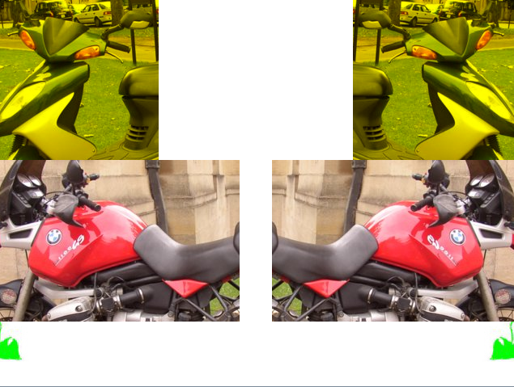

**Activity 9 Exercise Results**

1. Paste the image that is the result of calling the edgeDetection2 method.

I took a slightly different approach, so now the edges are detected both vertically and horizontally, which is ultimately the same result had I done it a more normal way.  
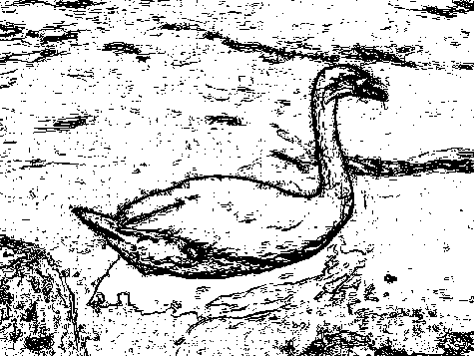

1. Think about and propose another algorithm for edge detection.  
   A good edge detection algorithm would not look at a single adjacent pixel for comparison. Rather, it would analyze pixel clusters, such as a 3 x 3 grid. By comparing the current pixel to the greatest and lowest distances of the surrounding pixels, it would very easily distinguish edges with varying degrees of intensity. In theory, more modern algorithms would factor in tolerance and angles of edges to increase the accuracy, but that is overkill for the sake of a simply efficient edge detection algorithm.